**PUBLIC TRANSPORTATION EFFICIENCY ANALYSIS**

**TEAM MEMBER** **732121104074: SRIKANTH L**

**PHASE-1 DOCUMENT SUBMISSION**

**PROJECT: PUBLIC TRANSPORTATION EFFICIENCY**

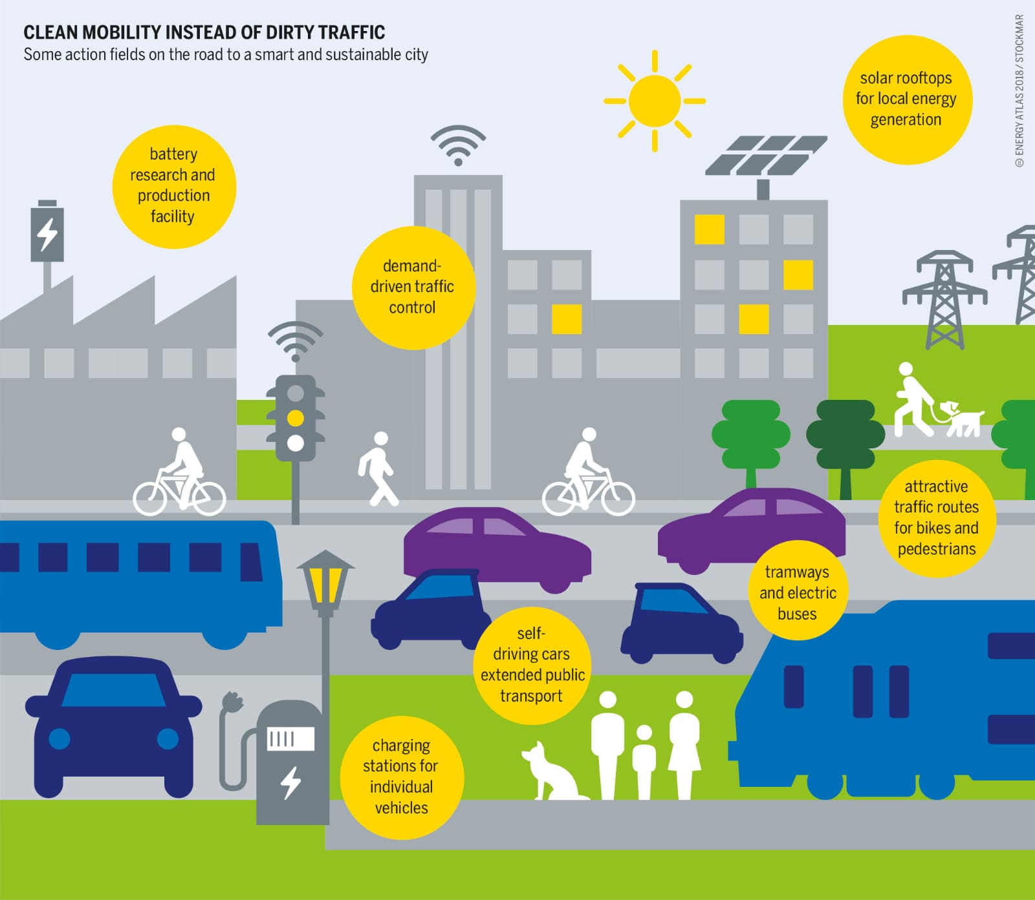

**ANALYSIS OBJECTIVES:**

 Define specific objectives for analyzing public transportation data, such as assessing on-time performance, passenger satisfaction, and service efficiency.

**PHASE 1:**PROBLEM DEFINITION AND DESIGN THINKING

**DATA SOURSE:**

Identify the sources and methods for collecting transportation data, including schedules, real-time updates, and passenger feedback.

**Dataset Link:** [**https://www.kaggle.com/datasets/rednivrug/unisys?select=20140711.CSV**](https://www.kaggle.com/datasets/rednivrug/unisys?select=20140711.CSV)

**ABSTRACT:**

Public transportation systems are essential components of modern urban infrastructure, aiming to provide convenient, cost-effective, and sustainable mobility solutions. To enhance the performance of these systems and optimize resource allocation, a comprehensive analysis of their efficiency is crucial. This paper proposes a structured approach to assess public transportation efficiency through various modules, each addressing specific aspects of the system. The analysis modules include ridership analysis, route optimization, resource utilization, environmental impact assessment, and passenger satisfaction evaluation. By systematically evaluating these components, transportation authorities and planners can make informed decisions to improve public transportation services, reduce operational costs, and contribute to the overall well-being of urban communities.

**MODULES:**

**Ridership Analysis Module:**

* Objective: To evaluate the ridership patterns of public transportation systems.
* Metrics: Daily, weekly, and monthly ridership data, passenger demographics, and fare collection data.
* Analysis Techniques: Ridership trends, peak-hour analysis, and spatial distribution of riders.

**Route Optimization Module:**

* Objective: To optimize routes for buses, trams, and trains to improve service efficiency.
* Metrics: Route length, travel time, and passenger density.
* Analysis Techniques: Network analysis, geographic information systems (GIS), and simulation models.

**Resource Utilization Module:**

* Objective: To assess the allocation of resources such as vehicles, personnel, and infrastructure.
* Metrics: Vehicle occupancy rates, driver schedules, and maintenance costs.
* Analysis Techniques: Resource allocation models, cost-benefit analysis, and operational efficiency metrics.

**Environmental Impact Assessment Module:**

* Objective: To measure the environmental footprint of public transportation systems.
* Metrics: Carbon emissions, fuel consumption, and air quality.
* Analysis Techniques: Emission modeling, life-cycle assessment, and alternative fuel analysis.

**Passenger Satisfaction Evaluation Module:**

* Objective: To gauge passenger satisfaction and identify areas for improvement.
* Metrics: Surveys, feedback data, and complaint records.
* Analysis Techniques: Sentiment analysis, customer journey mapping, and service quality assessment.

**Integration and Decision Support Module:**

* Objective: To integrate findings from the previous modules and provide decision support.
* Metrics: Key performance indicators (KPIs) derived from the analysis modules.
* Analysis Techniques: Multi-criteria decision analysis, scenario modeling, and data visualization.

**Recommendation and Implementation Module:**

* Objective: To propose actionable recommendations based on the analysis.
* Metrics: Prioritized recommendations, estimated impact, and implementation timelines.
* Analysis Techniques: Cost-effectiveness analysis, stakeholder engagement, and project planning.

By systematically applying these analysis modules, transportation authorities and planners can gain a holistic understanding of their public transportation systems, leading to data-driven decisions and improvements in efficiency, sustainability, and passenger satisfaction. This approach contributes to building smarter, more efficient, and environmentally friendly urban transportation systems for the future.